Name: Hamdy Ahmed Elsherbiny Ahmed

Section 3

Quiz 1

In the Hypothetical Machine the contents of memory was as shown. And PC contents is 300. Show the contents of memory and PC , AC , IR after execute three instructions (three fetch cycle and there execute cycle)

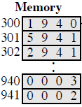

The sol:

Frist instruction:

* Fetching:

AC: 0000 IR: 1940 PC: 300

940: 0003 941: 0002

* EXECUTION:

AC: 0003 IR : 5940 PC: 300

940: 0003 941: 0002

Second instruction:

* Fetching:

AC: 0005 IR: 2941 PC: 302

940 : 0003 941: 0005

* Execution:

AC: 0000 IR: 2941 PC: 302

940: 0003 941 : 0002

Third instruction:

* Fetching:

AC: 0005 IR: 2941 PC: 302

940: 0003 941: 0002

* EXECUTION:

AC: 0000 IR : 2941 PC: 302

940: 0003 941: 0005

Show the contents of PC , AC and IR and memory after the execution of each instruction of the following program on the Hypothetical Machine:

300 LOAD 550

301 ADD 551

302 STORE 600

Where the contents of memory at 550 is 3 and at 551 is 4.

The sol:

Frist instruction:

* Fetching:

AC: 0000 IR: 1550 PC: 300

550: 0003 551: 0004 600: 0000

* EXECUTION:

AC: 0003 IR : 1550 PC: 301

550: 0003 551: 0002 600 : 0000

Second instruction:

* Fetching:

AC: 0003 IR: 5551 PC: 301

550 : 0003 551: 0004 600: 0000

* Execution:

AC: 0007 IR: 5551 PC: 301

550: 0003 551 : 0004 6000: 0000

Third instruction:

* Fetching:

AC: 0007 IR: 2600 PC: 302

550: 0003 551: 0004 600: 0007

* EXECUTION:

AC: 0000 IR : 2600 PC: 302

550: 0003 551: 0004 600: 0007

The following figure provide the main characteristics of Hypothetical Machine.

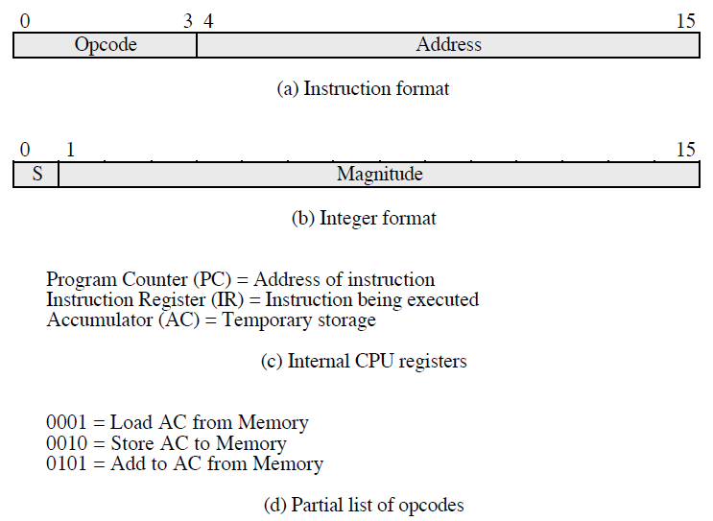

The hypothetical machine also has two I/O instructions:

0011 = load AC from I/O

0111 =store AC to I/O

In these case, the 12-bi address identifies a particular I/O device. Show the program execution for the following program:

1. Load AC from device 5.

2. Add contents of memory location 940.

3. Store AC to device 6.

Assume that the next value retrieved from device 5 is 3 and that location 940 contains a value of 2.

**The answer:**

|  |
| --- |
| 300 **3005** |
| 301 **5940** |
| 302  **7006** |

**After executing the three instructions:**

Device 5: 0003

940: 2

Device 6: 0005